A MINI PROJECT ON

MACHINE LEARNING BASED HUMAN EMOTION RECOGNITION USING VARIATIONS IN BIOLOGICAL PARAMETERS
Submitted to the

JAWAHARLAL NEHRU TECHNOLOGICAL UNIVERSITY
KUKATPALLY, HYDERABAD

In partial fulfilment of the requirement for the award of the degree of

BACHELOR OF TECHNOLOGY
IN
ELECTRONICS & COMMUNICATION ENGINEERING

BY
LETHAKULA MANISH REDDY (177Y1A04D7)

Under the Guidance of
Dr. SRINIVAS NALLAGONDA
Associate Professor



DEPARTMENT OF ELECTRONICS AND COMMUNICATION ENGINEERING

August, 2020

Department of Electronics & Communication Engineering

Date:

CERTIFICATE

This is to certify that the project work entitled “MACHINE LEARNING BASED HUMAN EMOTION RECOGNITION USING VARIATIONS IN BIOLOGICAL PARAMETERS” work done by Lethakula Manish Reddy (1777Y1A04D7) student of Department of Electronics and Communication Engineering, is a record of bonafide work carried out by the members during a period from July, 2019 to November, 2019 under the supervision of Dr. Srinivas Nallagonda, Associate Professor. This project is done as a fulfilment of obtaining Bachelor of Technology Degree to be awarded by Jawaharlal Nehru Technological University Hyderabad, Hyderabad.
The matter embodied in this project report has not been submitted by us to any other university for the award of any other degree.

LETHAKULA MANISH REDDY

This is to certify that the above statement made by the candidates is correct to the best of my/our knowledge.
Dr. Srinivas Nallagonda
Date:________
The Viva-Voce Examination of above students, has been held on………………………………

Head of the Department Signature of External Examiner

Principal

ACKNOWLEDGEMENTS
We would like to express my sincere gratitude to my guide Dr. Srinivas Nallagonda, Associate Professor, Department of Electronics and Communication Engineering, for his excellent guidance and invaluable support, which helped me accomplish the B.Tech (ECE) degree and prepared me to achieve more life goals in the future. His total support of my dissertation and countless contributions to my technical and professional development made for a truly enjoyable and fruitful experience. Special thanks are dedicated for the discussions we had on almost every working day during my project period and for reviewing my dissertation.
We are very much grateful to our Project Co-ordinator, Dr. Shijin Kumar P.S, Associate Professor, Department of ECE, MLRITM, Dundigal, Hyderabad, who has not only shown utmost patience, but was fertile in suggestions, vigilant in directions of error and has been infinitely helpful.
We are extremely grateful to Dr. Srinivas Bachu, Associate Professor & HOD-ECE, MLRITM, Dundigal, Hyderabad, for the moral support and encouragement given in completing my project work.
We wish to express deepest gratitude and thanks to Dr. K. Venkateswara Reddy, Principal, MLRITM, for his constant support and encouragement in providing all the facilities in the college to do the project work.
We would also like to thank all our faculties, administrative staff and management of MLRITM, who helped me to completing the mini project.
On a more personal note, we thank our beloved parents and friends for their moral support during the course of our project.

TABLE OF CONTENTS
Certificate  Acknowledgements  Table of Contents  List of Figures viii  List of Abbreviations  Abstract |  | ii  iii  iv  vi  vii  viii
Chapter 1: Introduction |  | 1-3
 | - Introduction  - Alexithymia  - Causes of Alexithymia  - Diagnosis  - Motivation  - Organization of the Report | 1  1  2  2  3  3
Chapter 2: Literature Survey |  | 4-6
 | 2.1 Introduction  2.2 Text based Emotion Recognition  2.3 Speech Emotion Recognition  2.4 Facial Emotion Recognition | 4  4  5  5
Chapter 3: Methodology |  | 7-27
 | 3.1 Introduction  3.2 Tools Required  - Introduction to ML  - Alexithymia  3.3.2 Machine Learning: How it works  3.3.3 Advantages of Machine Learning  3.3.4 Methods are used in Machine Learning  3.3.5 Types of Machine Learning  3.3.6 Application of Machine Learning  3.3.7 Machine Learning: The technology leaders  3.4 Introduction to Pandas:  3.4.1 Python Pandas Data Frame  3.5 Working with Pandas  3.5.1 Loading and Saving Data with Pandas  3.5.2 Viewing and Inspecting Data  3.5.3 Selection of Data  3.5.4 Data Cleaning  3.6 Numpy  3.7 Sklearn  3.7.1 Gaussian Naïve Bayes  3.8 Tkinter  3.9 Python  3.10 Methodology  3.10.1 Data Collection  3.10.2 Data Processing  3.10.3 Model Fitting  3.11 Block Diagram | 7  7  7  7  8  8  9  9  10  11  12  12  13  13  13  14  14  15  15  16  17  18  18  19  20  24  27
Chapter 4: Results Analysis |  | 28-32
 | 4.1 Introduction  4.2 Classification Report  4.3 Confusion Matrix  4.4 Graphical User Interface | 28  28  29  29
Chapter 5: Applications |  | 33-34
 | 5.1 Applications  5.2 Advantages  5.3 Disadvantages | 33  33  34
Chapter 6: Conclusion and Future Scope of Work |  | 35
 | 6.1 Conclusion  6.2 Future Scope | 35  35
References |  | 36-37
Annexure |  | 38-41

LIST OF FIGURES
Figure No. | Name of the Figure | Page No.
Figure 2.1  Figure 2.2  Figure 2.3  Figure 3.1  Figure 3.2  Figure 3.3  Figure 3.4  Figure 3.5  Figure 3.6  Figure 3.7  Figure 3.8  Figure 3.9  Figure 3.10  Figure 4.1  Figure 4.2  Figure 4.3  Figure 4.4  Figure 4.5 | Illustration of Text Based Emotion detection model  Illustration of Speech Based Emotion detection mod  Illustration of Facial Expression Emotion Recognition  Proposed Model Overview  Description of the dataset  Relation between Emotion and Systolic pressure Relation between Emotion and Diastolic pressure  Relation between Emotion and Heartrate  Relation between Emotion and Pulse_rate  Relation between Emotion and Blood Viscosity  Correlation plot of the attributes in dataset  Categorical data verification  Block diagram of model  Classification report  Confusion Matrix  GUI  Test-1  Test-2 | 4  5  6  19  20  20  21  21  22  22  23  23  27  28  29  30  31  32

LIST OF ABBREVIATIONS
ML  DL  AI  GUI  BP | Machine Learning  Deep Learning  Artificial Intelligence  Graphical User Interface  Blood Pressure

ABSTRACT
Human life is incomplete without emotional communication. Ten percent of the world’s population are unable to express their emotions through facial expressions. This is due to psychological condition called ‘Alexithymia’. Person suffering with Alexithymia cannot express their emotions or feelings even though the biological parameters like B.P, heart rate, blood viscosity, pulse rate are affected. Creating a user interface which considers these biological parameters to predict emotion could be more effective while treating the people having this condition. This can be achieved using Machine learning algorithms. Photo-plethysmograph is used to determine the biological parameters measured by an oximeter. Earlier, emotion is determined using facial expressions. But later on, advancement of technology allowed us to determine human emotion using Heart rate and skin conductivity. Many emotion detectors are available which takes facial expressions as a main aspect but as this is not feasible in this case, we need to consider the biological parameters to predict the emotion and help a person with Alexithymia communicate emotionally.

CHAPTER 1
INTRODUCTION
  - INTRODUCTION
Emotion is a mental state associated with the nervous system brought on by chemical changes variously associated with thoughts, feelings, behavioral responses, and a degree of pleasure or displeasure. There is currently no scientific consensus on a definition. "Emotions can be defined as a positive or negative experience that is associated with a particular pattern of physiological activity." Emotions produce different physiological, behavioral and cognitive changes. Every emotion has its own physiological parameter (Heart Rate, Blood Pressure, Pulse Rate, Blood Viscosity etc.,) values.
    - Alexithymia
Alexithymia (literally ‘no words for feelings’) refers to a person's inability to identify or verbally describe his or her feelings. The psychiatric syndrome is prevalent in patients with psychosomatic problems, and anxiety disorders, but alexithymic symptoms occur along a continuum. Perhaps you know someone who doesn't seem to express their emotions very well.
Peter Sifneos, a psychiatrist and professor emeritus of psychiatry at Harvard Medical School, first described alexithymia in the early 1970s. The word comes from Greek: 'a' meaning lack, 'lexis' meaning word, and 'thymos' meaning emotion — overall, it means having a lack of words for emotions.
People with alexithymia have:
- problems with introspection, or observing their own mental and emotional processes.
- experience confusion around bodily sensations connected to emotions.
- struggle to communicate their emotions with others.
Alexithymia also makes it difficult for people to identify and respond to emotions in others. These issues can lead to difficulties in social settings and interpersonal relationships.

    - Causes of Alexithymia
A person may be more at risk of alexithymia if they have a close relative with the condition.
Experts do not understand the exact cause of alexithymia. Some studies suggest that it may result from one or more of the following:
- Genetics. Research on twins indicates that there is a genetic component to alexithymia. People are more likely to have alexithymia if a close relative also has it.
- Environmental factors. The same twin study also indicates that environmental factors play a role in alexithymia. Examples of environmental factors include a history of childhood trauma, the presence of a physical or mental health condition, or socioeconomic factors.
- Brain injury. Research reports that people with injury to a part of the brain known as the anterior insula experience increased levels of alexithymia.

    - Diagnosis:
Alexithymia is not a physical health disorder, so doctors and mental health professionals cannot formally diagnose the phenomenon. However, there are questionnaires and scales that professionals can use to check for signs of alexithymia.
These include:
The Twenty-Item Toronto Alexithymia Scale (TAS-20) that assesses:
- a person's ability to identify feelings and to separate these from physical sensations
- their ability to communicate feelings to other people
- their inclination to show externally oriented thinking (rather than an introspective thinking style)
Treating a patient having alexithymia requires continuous monitoring over his psychological emotional state. Considering biological parameters like Heart Rate, Blood Pressure, Pulse Rate, Blood Viscosity to predict emotion could be more effective while treating the people having this condition.
  - MOTIVATION:

The key motivation, is building a model or system which can detect the emotion in a more sophisticated way of using basic biological parameters rather than using facial features which becomes quite complex in case of Alexithymia.
  - ORGANIZATION OF REPORT:

This report is divided into 5 parts. The Chapter-1 is Introduction which gives idea about the project and its importance. Chapter-2 is Literature survey which tells all about various emotion recognition techniques. Chapter-3 is Methodology involves in development of the model and the expiation about the requirements. Results, and accuracy analysis are described in Chapter-4. In Chapter-5 various applications, pros and cons of using this model are discussed. Finally, in Chapter-6 conclusion and future scope are explained.

CHAPTER 2

LITERATURE SURVEY
- INTRODUCTION

Emotion defines what do we feel about something. Emotion recognition is the approach of identifying human emotion. Humans show a lot variability in their abilities to recognize and analyze emotion. There are many ways of assessing or identifying emotion. Identifying a person’s emotion using his biological parameters is one way which can be used in a generalized way. Some prominent and popular techniques from the literature are discussed in this chapter to give an overview of the relevant.

- Text Based Emotion Recognition

Text based emotion recognition is an approach where a sentence or paragraph is divided in to small keywords or tokens. These key words are fed into a pre trained AI model (Emotion Extractor) which will analyze all the keywords with the dataset or knowledge base it was trained and classify the text into the emotion classes which the text might corresponds.

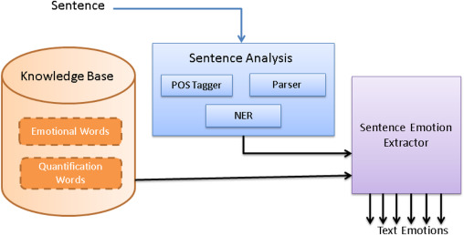

Figure 2.1 Illustration of Text Based Emotion detection model

- Speech Emotion Recognition
In speech-based emotion recognition a Deep Learning or AI model is trained using the pre processed training samples which extracts the key features like pitch, tone, and the speed of the audio. When a new audio is fed to the system for recognition it wills process the audio and compare the weights of the key feature with the model weights and classify them.

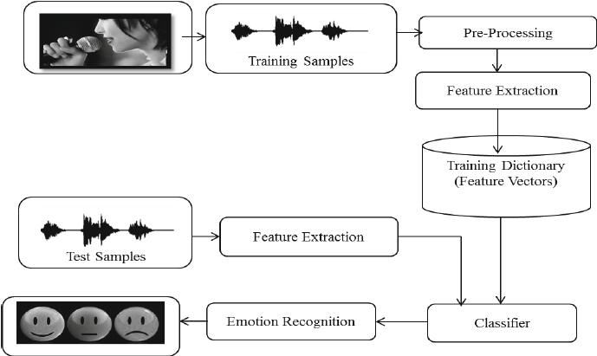

Figure 2.2 Illustration of Speech Based Emotion detection model
The speech emotion recognition in the past decade has shown an exponential grown in developing humanoid robots and virtual assistants

- Facial Emotion Recognition
Facial emotion recognition is the process of detecting human emotions from facial expressions. The human brain recognizes emotions automatically, and software has now been developed that can recognize emotions as well. This technology is becoming more accurate all the time, and will eventually be able to read emotions as well as our brains do.

AI can detect emotions by learning what each facial expression means and applying that knowledge to the new information presented to it. Emotional artificial intelligence, or emotion AI, is a technology that is capable of reading, imitating, interpreting, and responding to human facial expressions emotions.

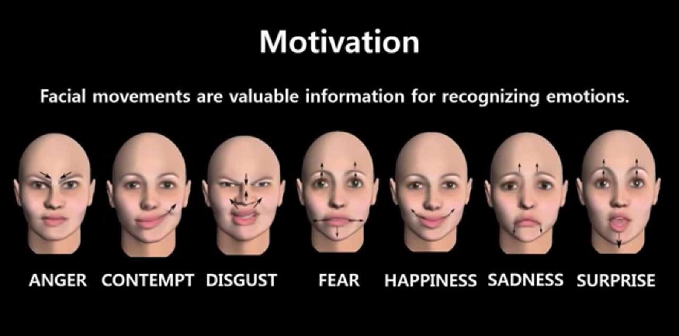
Figure 2.3 Illustration of Facial Expression Emotion Recognition

CHAPTER 3

METHODOLOGY

3.1 INTODUCTION

In this chapter we will discuss about the methodology of developing this machine learning model.

3.2 TOOLS REQUIRED

Tools required for developing this
      - Machine Learning
      - Pandas
      - Python
      - SKLearn
      - Tkinter

3.3 Introduction to ML:

3.3.1 Machine Learning — Definition
Machine Learning is a sub-area of artificial intelligence, whereby the term refers to the ability of IT systems to independently find solutions to problems by recognizing patterns in databases. In other words: Machine Learning enables IT systems to recognize patterns on the basis of existing algorithms and data sets and to develop adequate solution concepts. Therefore, in Machine Learning, artificial knowledge is generated on the basis of experience.
In order to enable the software to independently generate solutions, the prior action of people is necessary. For example, the required algorithms and data must be fed into the systems in advance and the respective analysis rules for the recognition of patterns in the data stock must be defined. Once these two steps have been completed, the system can perform the following tasks by Machine Learning:
- Finding, extracting and summarizing relevant data
- Making predictions based on the analysis data
- Calculating probabilities for specific results
- Adapting to certain developments autonomously
- Optimizing processes based on recognized patterns

3.3.2 Machine Learning: How it works
In a way, Machine Learning works in a similar way to human learning. For example, if a child is shown images with specific objects on them, they can learn to identify and differentiate between them. Machine Learning works in the same way: Through data input and certain commands, the computer is enabled to "learn" to identify certain objects (persons, objects, etc.) and to distinguish between them. For this purpose, the software is supplied with data and trained. For instance, the programmer can tell the system that a particular object is a human being (="human") and another object is not a human being (="no human"). The software receives continuous feedback from the programmer. These feedback signals are used by the algorithm to adapt and optimize the model. With each new data set fed into the system, the model is further optimized so that it can clearly distinguish between "humans" and "non-humans" in the end.

3.3.3 Advantages of Machine Learning
Machine Learning undoubtedly helps people to work more creatively and efficiently. Basically, you too can delegate quite complex or monotonous work to the computer through Machine Learning - starting with scanning, saving and filing paper documents such as invoices up to organizing and editing images.
In addition to these rather simple tasks, self-learning machines can also perform complex tasks. These include, for example, the recognition of error patterns. This is a major advantage, especially in areas such as the manufacturing industry: the industry relies on continuous and error-free production. While even experts often cannot be sure where and by which correlation a production error in a plant fleet arises, Machine Learning offers the possibility to identify the error early - this saves downtimes and money.

3.3.4 Methods are used in Machine Learning
In Machine Learning, statistical and mathematical methods are used to learn from data sets. Dozens of different methods exist for this, whereby a general distinction can be made between two systems, namely symbolic approaches on the one hand and sub-symbolic approaches on the other. While symbolic systems are, for example, propositional systems in which the knowledge content, i.e., the induced rules and the examples are explicitly represented, sub-symbolic systems are artificial neuronal networks. These work on the principle of the human brain, whereby the knowledge contents are implicitly represented.

3.3.5 Types of Machine Learning
Basically, algorithms play an important role in Machine Learning: On the one hand, they are responsible for recognizing patterns and on the other hand, they can generate solutions. Algorithms can be divided into different categories:
Supervised learning: In the course of monitored learning, example models are defined in advance. In order to ensure an adequate allocation of the information to the respective model groups of the algorithms, these then have to be specified. In other words, the system learns on the basis of given input and output pairs. In the course of monitored learning, a programmer, who acts as a kind of teacher, provides the appropriate values for a particular input. The aim is to train the system in the context of successive calculations with different inputs and outputs and to establish connections.
Unsupervised learning: In unsupervised learning, artificial intelligence learns without predefined target values and without rewards. It is mainly used for learning segmentation (clustering). The machine tries to structure and sort the data entered according to certain characteristics. For example, a machine could (very simply) learn that coins of different colours can be sorted according to the characteristic "colour" in order in order to structure them.
Partially supervised learning: Partially supervised learning is a combination of supervised and unsupervised learning.
Encouraging learning: Reinforcing learning - just like Skinner's classic conditioning - is based on rewards and punishments. The algorithm is taught by a positive or negative interaction which reaction to a certain situation should take place.
Active learning: Within the framework of active learning, an algorithm is given the opportunity to query results for specific input data on the basis of pre-defined questions that are considered significant. Usually, the algorithm itself selects questions with high relevance.
In general, the data basis can be either offline or online, depending on the corresponding system. In addition, it can be available only once or repeatedly for Machine Learning. Another distinguishing feature is the either staggered development of the input and output pairs or their simultaneous presence. On the basis of this aspect, a distinction is made between so-called sequential learning and so-called batch learning.
3.3.6 Application of Machine Learning
With the help of Machine Learning, economic data can be turned into money. Companies that rely on Machine Learning or Machine Learning methods are not only able to increase the satisfaction of their customers, but also to achieve cost reductions at the same time.
In addition, Machine Learning can help companies to find out whether there is a threat of customer migration in the near future. This is achieved, for example, through the automatic evaluation of support requests. An alternative is to analyse those characteristics that customers who have already migrated in the past have in common. If those existing customers who also have these characteristics are then filtered out on the basis of the characteristics resulting from the analysis, the company receives a list of the customer group at risk of migration. Appropriate measures can then be taken to retain these customers.
Acquisition of landmines in acoustic sensor and radar data in addition, more and more chat bots are being used in the area of telephone service. These are automated programs that communicate with customers. In this way, the chat bots can optimize their cognitive abilities with regard to the interpretation of the tone in different situations. In addition, the chat bots are able to forward the call - for example, if it is a more complex request - to an employee of the call centre.
Furthermore, Machine Learning is a key technology in the development of autonomous systems: In addition to driverless cars, Machine Learning is also used in collaborative robots. Other areas of application for Machine Learning would be:
- Analysis of the stock market
- Credit Card Fraud Detection
- Automated diagnostic procedures
- Extra-terrestrial anomaly detection
    - Machine Learning: The technology leaders
In addition to Microsoft, Google, Facebook, IBM and Amazon, Apple also spends enormous financial resources on the use and further development of Machine Learning. IBM's Watson supercomputer is still the best-known appliance for Machine Learning. Watson is mainly used in the medical and financial sectors. Facebook uses Machine Learning for image recognition, Microsoft for the speech recognition system Cortana, Apple for Siri. Machine Learning is also used at Google, both in the area of image services and search engine ranking.
Cloud providers such as Google, Microsoft, Amazon Webservice and IBM have now created services for Machine Learning. With their help it is also possible for developers who do not have specific Machine Learning knowledge to develop applications. These applications are able to learn from a freely definable set of data. Depending on the provider, these platforms have different names:
- IBM: Watson
- Amazon: Amazon Machine Learning
- Microsoft: Azure ML Studio
- Google: TensorFlow
In addition to the platforms mentioned above, there is a broad spectrum of high-quality, free open-source programs through which Machine Learning has been made accessible to a wider audience.

  - Introduction to Pandas:
Pandas is a Python library to deal with sequential and tabular data. It includes many tools to manage, analyze and manipulate data in a convenient and efficient manner. We can think of its data structures as akin to database tables or spreadsheets.
Pandas is built on top of the NumPy library and has two primary data structures viz. Series (1-dimensional) and DataFrame (2-dimensional). It can handle both homogeneous and heterogeneous data, and some of its many capabilities are:
- ETL tools (Extraction, Transformation and Load tools)
- Dealing with missing data (NaN)
- Dealing with data files (csv, xls, db, hdf5, etc.)
- Time-series manipulation tools
In the Python ecosystem, Pandas is the best choice to retrieve, manipulate, analyze and transform financial data.

3.4.1 Python Pandas Data Frame
The second data structure in Python Pandas that we are going to see is the Data Frame. Python Pandas Data Frame is a heterogeneous two-dimensional object, that is, the data are of the same type within each column but it could be a different data type for each column and are implicitly or explicitly labelled with an index.

3.5 Working with Pandas

3.5.1 Loading and Saving Data with Pandas
When we want to use Pandas for data analysis, we usually use it in one of three different ways:
- Convert a Pythons list, dictionary or NumPy array to a Pandas data frame
- Open a local file using Pandas, usually a CSV file, but could also be a delimited text file (like TSV), Excel, etc
- Open a remote file or database like a CSV or a JSON on a website through a URL or read from a SQL table/database
There are different commands to each of these options, but when we open a file, they would look like this:
pd.read_filetype()
In order to convert a certain Python object (dictionary, lists etc) the basic command is:
pd.DataFrame()
To save a data frame we are working on to different kinds of files (like CSV, Excel, JSON and SQL tables). The general code for that is:
df.to_filetype(filename)

3.5.2 Viewing and Inspecting Data
Now that we loaded our data, it’s time to take a look. Running the name of the data frame would give us the entire table, but we can also get the first n rows with df.head(n) or the last n rows with df.tail(n).
df.shape would give us the number of rows and columns.
df.info( ) would give you the index, datatype and memory information.
The command s.value_counts(dropna=False) would allow you to view unique values and counts for a series (like a column or a few columns).
A very useful command is df.describe() which inputs summary statistics for numerical columns. It is also possible to get statistics on the entire data frame or a series (a column etc):
- df.mean() Returns the mean of all columns
- df.corr() Returns the correlation between columns in a data frame
- df.count() Returns the number of non-null values in each data frame column
- df.max() Returns the highest value in each column
- df.min() Returns the lowest value in each column
- df.median() Returns the median of each column
- df.std() Returns the standard deviation of each column

3.5.3 Selection of Data
One of the things that is so much easier in Pandas is selecting the data we want in comparison to selecting a value from a list or a dictionary. we can select a column (df[col]) and return column with label col as Series or a few columns (df[[col1, col2]]) and returns columns as a new DataFrame. We can select by position (s.iloc[0]), or by index (s.loc['index_one']) . In order to select the first row we can use df.iloc[0,:] and in order to select the first element of the first column you would run df.iloc[0,0] . These can also be used in different combinations, so I hope it gives you an idea of the different selection and indexing you can perform in Pandas.

3.5.4 Data Cleaning
Data cleaning is a very important step in data analysis. For example, we always check for missing values in the data by running pd.isnull() which checks for null Values, and returns a boolean array (an array of true for missing values and false for non-missing values). In order to get a sum of null/missing values, run pd.isnull().sum(). pd.notnull() is the opposite of pd.isnull(). After you get a list of missing values you can get rid of them, or drop them by using df.dropna() to drop the rows or df.dropna(axis=1) to drop the columns. A different approach would be to fill the missing values with other values by using df.fillna(x) which fills the missing values with x (you can put there whatever you want) or s.fillna(s.mean()) to replace all null values with the mean (mean can be replaced with almost any function from the statistics section).
3.6 NUMPY
NumPy is a Python package. It stands for 'Numerical Python'. It is a library consisting of multidimensional array objects and a collection of routines for processing of array. Numeric, the ancestor of NumPy, was developed by Jim Hugunin. Another package Numarray was also developed, having some additional functionalities. In 2005, Travis Oliphant created NumPy package by incorporating the features of Numarray into Numeric package. There are many contributors to this open-source project. Operations using NumPy Using NumPy, a developer can perform the following operations:
• Mathematical and logical operations on arrays.
• Fourier transforms and routines for shape manipulation.
• Operations related to linear algebra. NumPy has in-built functions for linear algebra and random number generation.
3.7. SKLEARN
In general, a learning problem considers a set of n samples of data and then tries to predict properties of unknown data. If each sample is more than a single number and, for instance, a multi-dimensional entry (aka multivariate data), it is said to have several attributes or features.Learning problems fall into a few categories:
- Supervised learning, in which the data comes with additional attributes that we want to predict (Click here to go to the scikit-learn supervised learning page). This problem can be either:
- Classification: samples belong to two or more classes and we want to learn from already labeled data how to predict the class of unlabeled data. An example of a classification problem would be handwritten digit recognition, in which the aim is to assign each input vector to one of a finite number of discrete categories. Another way to think of classification is as a discrete (as opposed to continuous) form of supervised learning where one has a limited number of categories and for each of the n samples provided, one is to try to label them with the correct category or class.
- Regression: if the desired output consists of one or more continuous variables, then the task is called regression. An example of a regression problem would be the prediction of the length of a salmon as a function of its age and weight.
- Unsupervised learning, in which the training data consists of a set of input vectors x without any corresponding target values. The goal in such problems may be to discover groups of similar examples within the data, where it is called clustering, or to determine the distribution of data within the input space, known as density estimation, or to project the data from a high-dimensional space down to two or three dimensions for the purpose of visualization
3.7.1 GAUSSIAN NAÏVE BAYES
Naive Bayes classifiers are a collection of classification algorithms based on Bayes’ Theorem. It is not a single algorithm but a family of algorithms where all of them share a common principle, i.e. every pair of features being classified is independent of each other. The dataset is divided into two parts, namely, feature matrix and the response vector.
- Feature matrix contains all the vectors (rows) of dataset in which each vector consists of the value of dependent features. In the dataset, features are ‘Systolic Pressure’, ‘Diastolic Pressure, ‘Heart Beat, ‘Pulse rate, ‘Blood Viscosity’.
- Response vector contains the value of class variable (prediction or output) for each row of feature matrix. In above dataset, the class variable name is ‘Emotion.
The fundamental Naive Bayes assumption is that each feature makes an:
- independent
- equal
Contribution to the outcome.

Bayes’ Theorem finds the probability of an event occurring given the probability of another event that has already occurred. Bayes’ theorem is stated mathematically as the following equation:
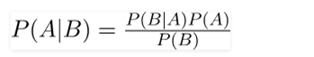
where A and B are events and P(B) ? 0.
- Basically, we are trying to find probability of event A, given the event B is true. Event B is also termed as evidence.
- P(A) is the priori of A (the prior probability, i.e. Probability of event before evidence is seen). The evidence is an attribute value of an unknown instance (here, it is event B).
- P(A|B) is a posteriori probability of B, i.e. probability of event after evidence is seen.
In Gaussian Naive Bayes, continuous values associated with each feature are assumed to be distributed according to a Gaussian distribution. A Gaussian distribution is also called Normal distribution. When plotted, it gives a bell-shaped curve which is symmetric about the mean of the feature values as shown below:

The likelihood of the features is assumed to be Gaussian; hence, conditional probability is given by:
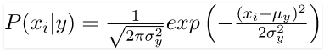

3.8 Tkinter
Tkinter is a Python binding to the Tk GUI (Graphical User Interface) toolkit. It is the standard Python interface to the Tk GUI toolkit, and is Python's de facto standard GUI. Tkinter is included with standard Linux, Microsoft Windows and Mac OS installs of Python.The name Tkinter comes from Tk interface. Tkinter was written by Fredrik Lundh.Tkinter is free software released under a Python license.

Tkinter is the standard GUI library for Python. Python when combined with Tkinter provides a fast and easy way to create GUI applications. Tkinter provides a powerful object-oriented interface to the Tk GUI toolkit.
Creating a GUI application using Tkinter is an easy task. All you need to do is perform the following steps −
- Import the Tkinter module.
- Create the GUI application main window.
- Add one or more of the above-mentioned widgets to the GUI application.
- Enter the main event loop to take action against each event triggered by the user.
3.9 Python

Python is a multiparadigm, general-purpose, interpreted, high-level programming language. Python allows programmers to use different programming styles to create simple or complex programs, get quicker results and write code almost as if speaking in a human language.
3.10 Methodology
Every emotion has some specific range of the physiological changes in our body due to secretion of adrenaline. Suppose, if a person is in fear then his heart rate gets elevated and if he is angry his blood pressure increases, and if he is stressed his blood pressure increases. Designing a Machine Learning system which will consider Biological parameters like Heart Rate, Blood Pressure, Pulse Rate, Blood Viscosity and classify them according to the respective emotions like Happy, Sad, Stressed, Depressed, Angry.
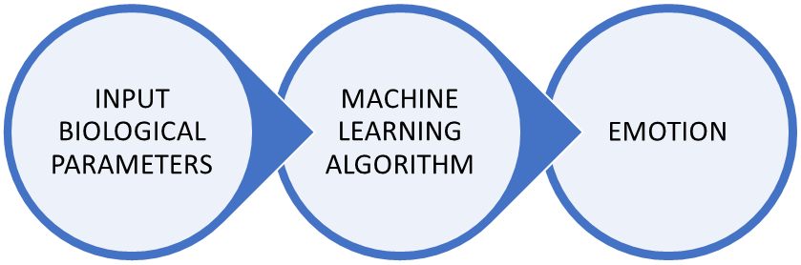Figure 3.1 Proposed Model Overview
3.10.1 Data collection
To develop the Machine Learning model, a data set consisting of biological parameter values of 4207 tests, each having 6 attributes is collected with the help of neuro physicians form various Institutes of Mental Health & Neuro Sciences. The attributes or inputs are SYSTOLIC_PRESSURE, DIASTOLIC_PRESSURE, HEART_RATE, PULSE_RATE, BLOOD_VISCOSITY and the target EMOTION. Output has 5 labels namely Happy, Sad, Stressed, Depressed, Angry.
Systolic Pressure: Systolic pressure is the pressure of the blood in the arteries when the heart pumps. It is the higher of two blood pressure measurements; for example, if the blood pressure is 120/80, then 120 is the systolic pressure.
Diastolic Pressure: Diastolic pressure is the pressure of the blood in the arteries when the heart is filling. It is the lower of two blood pressure measurements; for example, if the blood pressure is 120/80, then 80 is the diastolic pressure.
Heart rate: The number of heartbeats per unit of time, usually per minute. The heart rate is based on the number of contractions of the ventricles (the lower chambers of the heart). The heart rate may be too fast (tachycardia) or too slow (bradycardia).
Pulse rate: The pulse is a bulge of an artery from waves of blood that course through the blood vessels each time the heart beats. The pulse is often taken at the wrist to estimate the heart rate.
Blood viscosity: Blood viscosity is a measurement of the thickness and stickiness of an individual's blood. It is a direct measure of the ability of blood to flow through the blood vessels. It determines how much friction the blood causes against the vessels, how hard the heart has to work to pump the blood through the body, and how much oxygen is delivered to organs and tissues.
3.10.2 Data Processing
The dataset contains null values which are filled average values of the particular column. Using describe() function in pandas we can get the detailed picture of the dataset.
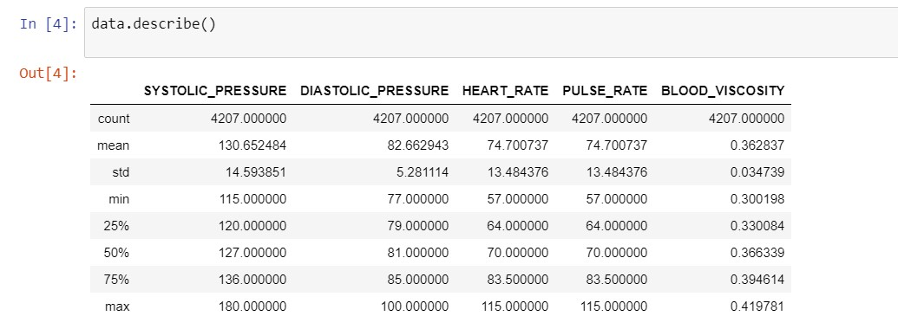
Figure 3.2 Description of the dataset
The relation between the inputs and output(Emotion) are
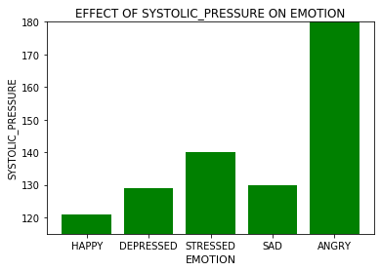
Figure 3.3 Relation between Emotion and Systolic_pressure
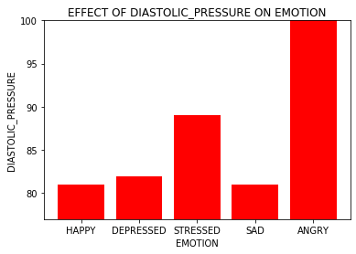
Figure 3.4 Relation between Emotion and Diastolic_pressure
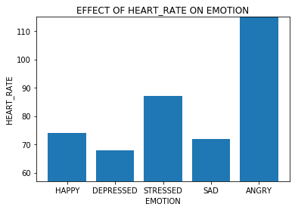
Figure 3.5 Relation between Emotion and Heart_rate
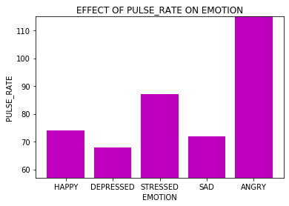
Figure 3.6 Relation between Emotion and Pulse_rate
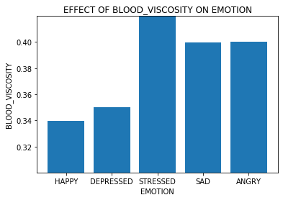
Figure 3.7 Relation between Emotion and Blood Viscosity

Correlation between variables can be visualized as

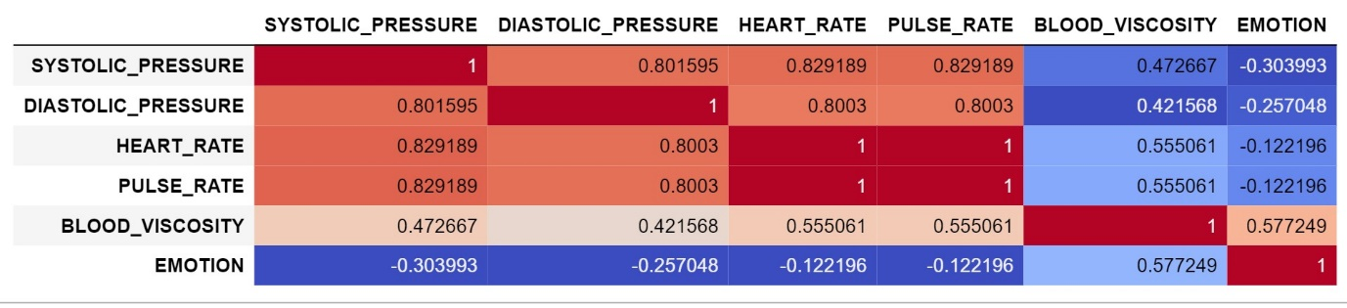
Figure 3.8 Correlation plot of the attributes in dataset

Now before going for the algorithm we need to check the data types of the variables.

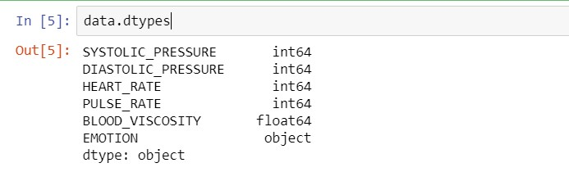

Figure 3.9 Categotical data verification

The dataset contains categorical data which is not suitable for many machine learning algorithms. This data needs to be encoded into numerical format which is understandable by the algorithm. The two techniques used to encode data are:
- Label Encoding: In this technique, each label is assigned a unique integer based on alphabetical ordering. from sklearn import preprocessing label_encoder = preprocessing.LabelEncoder()

data[EMOTION]= label_encoder.fit_transform(data[EMOTION])
- data One Hot Encoding: It simply creates additional features based on the number of unique values in the categorical feature. Every unique value in the category will be added as a feature.

encode_data=pd.get_dummies(x)

We will use Label encoding for encoding the categorical data.

Now all the object data types are enumerated. Only EMOTION in our data is object hence it is enumerated as
Angry – 0
Depressed – 1
Happy – 2
Sad – 3
Stressed – 4
‘x’ is labelled as input and ‘y’ is output or target.
Which is
x = {'SYSTOLIC_PRESSURE', 'DIASTOLIC_PRESSURE', 'HEART_RATE’,
'BLOOD_VISCOSITY'}
y = {'EMOTION'}
Data we have is splitted into training and testing data, where training data is thirty percent of total data and testing data is seventy percent.

3.10.3 Model Fitting
Gaussian Naïve Bayes model from Sklearn’s Naïve bayes is used for fitting the model and tested using the test data which is splitted earlier.

Code:
from sklearn.naive_bayes import GaussianNB
gnb = GaussianNB().fit(x_train, y_train)

The model is tuned and accuracy of 98.2%.

Now the model is saved using using jolib library usinf following commands.

joblib.dump(gnb, "model.pkl", compress=3)

This will generate a new pickle file ‘model.pkl’.

In a new python script we will create a user interface using tkinter we will use label, entry fields for each input

entries = {}

for field in fields:

print(field)

row = tk.Frame(root)

if field!='Emotion':

lab = tk.Label(row,

bg='#F7D8D8',

font=('times', 15, 'italic'),

width=20,

text=field+"",

anchor='w')

ent = tk.Entry(row,font=('times', 15, 'italic'))

ent.insert(0, "0")

else:

lab = tk.Label(row,

bg='#F7D8D8',

font=('times', 15, 'italic'),

width=20,

text=field+"",

anchor='w')

ent = tk.Entry(row,font=('times', 15, 'italic'))

ent.insert(0, "")

row.pack(side=tk.TOP,

fill=tk.X,

padx=10,

pady=10)

lab.pack(side=tk.LEFT)

ent.pack(side=tk.RIGHT,

expand=tk.YES,

fill=tk.X)

entries[field] = ent

We will load the saved model using joblib library using following command.

gnb = joblib.load("model.pkl")

When the inputs are given to the model it will classify the inputs based on the weights assigned by the model.

3.11 Block Diagram
PYTHON SCRIPT
Stored Data Set

Training and testing using GNB Classifier

GUI
Trained GNB Classifier
(Pickle file)
Parameter values to be entered by user

Emotion output
Decoding the output of the model

Figure 3.10 Block diagram of model

CHAPTER 4

RESULT ANALYSIS

4.1 INTODUCTION

In this chapter we will discuss about the accuracy of the model and the confusion matrix, Classification report and the final GUI developed.

4.2 Classification Report

A Classification report is used to measure the quality of predictions from a classification algorithm, to determine how many predictions are True and how many are False. More specifically, True Positives, False Positives, True negatives and False Negatives are used to predict the metrics of a classification report.

By using the Naïve Bayes classifier, we got the accuracy of 98.2% but to check whether the model is over fitted or under fitted we will use classification report.

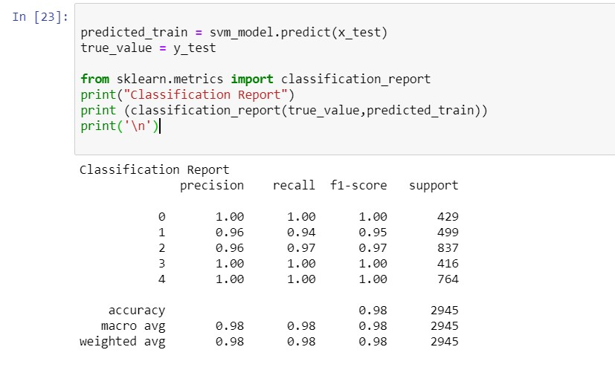

Figure 4.1 Clasification Report

The model correctly predicted all the observations of class 0,3,4, so both precision and recall are 1, and the F1-score is 1.

4.3 Confusion Matrix

A confusion matrix is a technique for summarizing the performance of a classification algorithm. Classification accuracy alone can be misleading if you have an unequal number of observations in each class or if you have more than two classes in your dataset.

Calculating a confusion matrix can give us a better idea of what our classification model is getting right and what types of errors it is making.

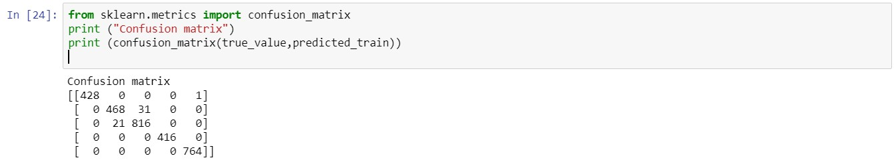

Figure 4.2 Confusion Matrix

4.4 Graphical User Interface

The GUI is developed using Python tkinter module. We created 5 Textboxes where we enter our input biological parameters and 2 buttons for ‘Prediction’ and ‘Exit’. When we click on Predict button, the values we entered are fed to the model loaded and the classified output is shown at the text box corresponding to emotion.

Here we have
- 2 Buttons (Find Emotion, Quit)
- 7 Labels (1 Title, 5 Inputs, 1 output)
- 6 Entry widgets (Corresponding to 5 Inputs and 1 output respectively)

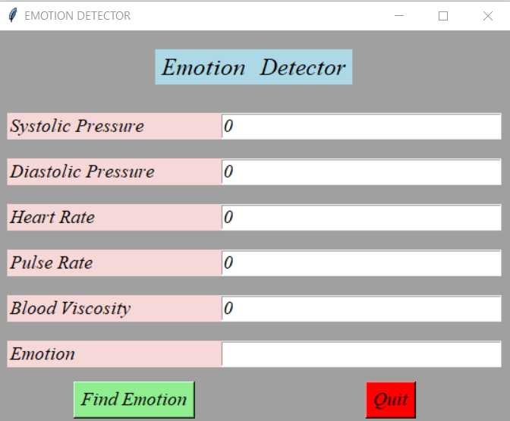

Figure 4.3 GUI

Initially all the values are predefinely set to Zero
- Test-1

If we enter the values as

Systolic Pressure : 121

Diastolic Pressure: 82

Heart Rate: 75

Pulse Rate: 75

Blood Viscosity: 0.3225

And click on ‘Find Emotion’

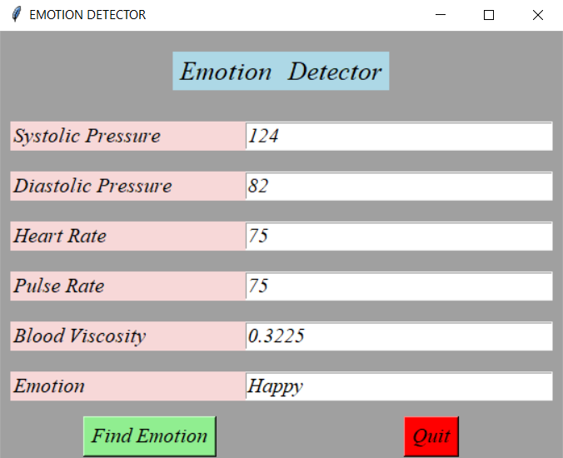

Figure 4.4 Test-1

The textbox corresponding to ‘Emotion’ gets updated as “Happy’

- Test-2

If we enter the values as

Systolic Pressure: 140

Diastolic Pressure: 85

Heart Rate: 80

Pulse Rate: 80

Blood Viscosity: 0.3531

And click on ‘Find Emotion’

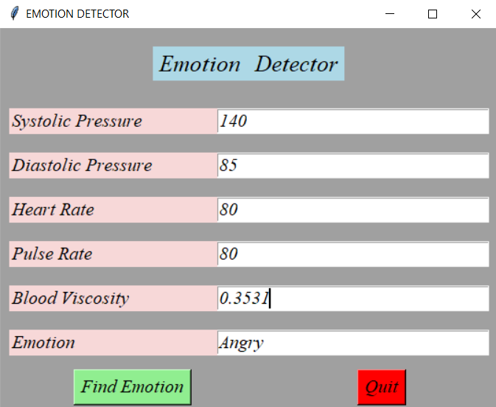

Figure 4.5 Test-2

The textbox corresponding to ‘Emotion’ gets updated as “Angry

CHAPTER 5
APPLICATIONS
  - APPLICATIONS
Human emotion recognition plays an important role in the interpersonal relationship. The automatic recognition of emotions has been an active research topic from early eras. Therefore, there are several advances made in this field. Emotions are reflected from speech, hand and gestures of the body and through facial expressions. Hence extracting and understanding of emotion has a high importance of the interaction between human and machine communication. There are a number of applications for this technology. Applications are spread across different fields like Medicine, E-learning, monitoring, Marketing, Entertainment and Law.
Some examples are:
- Old age health monitoring remotely, Counselling and determining client’s medical state.
- During healthcare, determining patients feeling and comfort level about the treatment
- In the case of Autism, Alexithymia struggling to interpret expressions
- In the case of eLearning, study the emotions and adjust the learning technique and presentation according to the style of learner.
  - ADVANTAGES
- This can be use as generalised way of detecting emotion.
- In case of Alexithymia and autism we cannot use facial expressions for emotion recognition where we can use this.
- We can use this to check the patients comfort during the treatment.
- The greater accuracy provides precise outcome without deviations.
- Fast response when compared to other methods.

  - DISADVANTAGES
- Manual entry of values which we are using at present takes human effort.
- Chances of human errors during the measurements and entering the values.
- As the values of the biological parameters changes, we need to develop hardware with very less response time.

CHAPTER 6
CONCLUSION AND FUTURE SCOPE OF WORK
6.1 CONCLUSIONS
In this project we designed a machine learning model using Gaussian Naïve Bayes Classifier which will take physiological/biological parameters like Blood Pressure, Heart rate, Pulse rate, Blood viscosity to classify them and predict the emotion.
This model classifies the values as Angry, Depressed, Happy, Sad, Stressed. This model predicts the emotion with 98.20% accuracy.
This model can be used to predict the emotion of the person who is suffering with Alexithymia. Person suffering with Alexithymia cannot express his emotions or feelings but his biological parameters like B.P, Heart Rate, Blood Viscosity, Pulse Rate are affected due to secretion of Adrenaline. In case of Alexithymic patient facial emotion recognition fails. So, this project will be more feasible for detecting the emotion.
6.2 FUTURE SCOPE
- Hardware implementation of this project will make more easier and live monitoring of the patient’s emotional state. This can be of a simple watch or a band or even a ring.
- This can be further developed by adding few other inputs like skin conductivity, and EEG can be used to means of communication to talk with paralyzed patients Bio sensors need to be used in this case.
- Can be developed as lie detecting system with proper fast input entry system which can be used in law enforcement.

REFERENCES

Journal / Conference Papers
- D.S.Quintana, A.J.Guastella, T.Outhred, I.B.Hickie, and A.H.Kemp. ‘Heart rate variability is associated with emotion recognition: direct evidence for a relationship between the autonomic nervous system and social cognition’. Int. J. of Psychophysiol, 86(2):168–172, 2012.

- Haag A., Goronzy S., Schaich P., Williams J. (2004) Emotion Recognition Using Bio-sensors: First Steps towards an Automatic System. In: André E., Dybkjær L., Minker W., Heisterkamp P. (eds) Affective Dialogue Systems. ADS 2004. Lecture Notes in Computer Science, vol 3068. Springer, Berlin, Heidelberg.

- L. Z. Ruiz, R. P. V. Alomia, A. D. Q. Dantis, M. J. S. San Diego, C. F. Tindugan and K. K. D. Serrano, "Human emotion detection through facial expressions for commercial analysis," 2017IEEE 9th International Conference on Humanoid, Nanotechnology, Information Technology, Communication and Control, Environment and Management (HNICEM), Manila, 2017, pp. 1-6, doi: 10.1109/HNICEM.2017.8269512.

- Kamble V.V., Deshmukh R.R., Karwankar A.R., Ratnaparkhe V.R., Annadate S.A. (2015) Emotion Recognition for Instantaneous Marathi Spoken Words. In: Satapathy S., Biswal B., Udgata S., Mandal J. (eds) Proceedings of the 3rd International Conference on Frontiers of Intelligent Computing: Theory and Applications (FICTA) 2014. Advances in Intelligent Systems and Computing, vol 328. Springer, Cham. https://doi.org/10.1007/978-3-319-12012-6_37

- Shu L, Yu Y, Chen W, et al. Wearable Emotion Recognition Using Heart Rate Data from a Smart Bracelet. Sensors (Basel). 2020;20(3):718. Published 2020 Jan 28. doi:10.3390/s20030718

ANNEXURES (optional)
Model Generator python code:
import numpy as np
import pandas as pd
import matplotlib.pyplot as plt
import joblib
data=pd.read_csv("Emotion.csv")

from sklearn.preprocessing import LabelEncoder
cat_var =data.dtypes.loc[data.dtypes == 'object'].index
le =LabelEncoder()
for var in cat_var:
data[var] = le.fit_transform(data[var])
x=data.iloc[:,0:5].values
y=data.iloc[:,5].values

from sklearn.model_selection import train_test_split
x_train,x_test,y_train,y_test=train_test_split(x,y,test_size=0.7)

#Naive Bayes classifier
from sklearn.naive_bayes import GaussianNB
gnb = GaussianNB().fit(x_train, y_train)
joblib.dump(gnb, "model.pkl", compress=3)

This will generate a ‘model.pkl’ file which is our classifier.

Predictor with GUI python code :
import joblib
import tkinter as tk
gnb = joblib.load("model.pkl")
def emopred(X):
Y= gnb.predict(X)
return Y

fields = ('Systolic Pressure','Diastolic Pressure', 'Heart Rate', 'Pulse Rate', 'Blood Viscosity', 'Emotion')
def Emotion(entries):
# period rate:
sys = float(entries['Systolic Pressure'].get())
dia =float(entries['Diastolic Pressure'].get())
har =float(entries['Heart Rate'].get())
pul =float(entries['Pulse Rate'].get())
bv=float(entries['Blood Viscosity'].get())
X=[[sys,dia,har,pul,bv]]
y=emopred(X)
if y==0:
emo='Angry'
elif y==1:
emo='Depressed'
elif y==3:
emo='Sad'
elif y==4:
emo='Stressed'
else:
emo='Happy'
entries['Emotion'].delete(0, tk.END)
entries['Emotion'].insert(0, emo )
def exit():
root.destroy()
def makeform(root, fields):
entries = {}
for field in fields:
print(field)
row = tk.Frame(root)
if field!='Emotion':
lab = tk.Label(row,bg='#F7D8D8',font=('times', 15, 'italic'), width=20, text=field+"", anchor='w')
ent = tk.Entry(row,font=('times', 15, 'italic'))
ent.insert(0, "0")
else:
lab = tk.Label(row,bg='#F7D8D8',font=('times', 15, 'italic'), width=20, text=field+"", anchor='w')
ent = tk.Entry(row,font=('times', 15, 'italic'))
ent.insert(0, "")
row.pack(side=tk.TOP,
fill=tk.X,
padx=10,
pady=10)
lab.pack(side=tk.LEFT)
ent.pack(side=tk.RIGHT,
expand=tk.YES,
fill=tk.X)
entries[field] = ent
return entries

if __name__ == '__main__':
root = tk.Tk()
root.title("EMOTION DETECTOR")
root.config(bg='#A0A0A0')
msg = tk.Message(root, text = 'Emotion \tDetector')
msg.config(bg='lightblue', font=('times', 19, 'italic'),aspect=200
)
msg.pack(side=tk.TOP, padx=100, pady=20)
ents = makeform(root, fields)
b1 = tk.Button(root, text='Find Emotion',bg='lightgreen',font=('times', 15, 'italic'),
command=(lambda e=ents: Emotion(e)))
b1.pack(side=tk.LEFT, padx=80, pady=5)
b2 = tk.Button(root, text='Quit',bg='red',font=('times', 15, 'italic'),command=exit)
b2.pack(side=tk.RIGHT, padx=100, pady=5)
root.mainloop()
Run Predictor.py to get the output.

